District Volunteering Development Team
The District Volunteering Development Team makes sure all volunteers in their District have a positive and enjoyable volunteering experience. They make it easy for people to join and learn new skills.
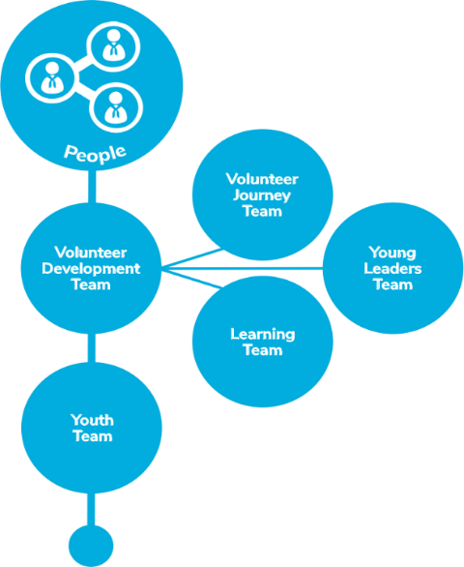
Team Members
- Volunteering Development Team leader  - Volunteering Development Team members  - Volunteer Journey Sub-team leader  - Volunteer Journey Sub-team members |  |  | - Young Leaders Sub-team leader  - Young Leaders Sub-team members  - Volunteer Learning Sub-team leader  - Volunteer Learning Sub-team members
Tasks
Tasks for the whole team
- Ensure that “our volunteering culture” is effectively embedded across the District and its Groups⁺
- Maintain relationships with groups and units
Allocated Tasks
Volunteer Development Team
Attract and welcome new volunteers to District and Group teams*
- Use Scouts branded resources to attract new volunteers
- Reply quickly and positively to possible new volunteers
- Make sure volunteers are welcomed easily and smoothly. Ensure that an accessible
and consistent welcoming experience is delivered across the district
- Hold inductions with Group Lead Volunteers and other Group and District Leadership Team Members.

Make sure volunteers are well supported
- Help and encourage Team Leaders (including Group Lead Volunteers) to have regular reviews with volunteers in their teams.
- Make sure all District teams (including Group Lead Volunteers) follow our approach to safe volunteer recruitment, appointment, reviews, and processes for leaving Scouts.

Recognise volunteers
- Recognise and appreciate volunteers for their brilliant work, formally and informally.
Volunteer Journey Sub-team
Welcome conversations and screening
- Contribute to a safe volunteer screening process
- Support groups to carry out welcome conversations with new volunteers
- Support groups to help ensure volunteers meet relevant mandatory requirements, such as learning, references disclosure checks, etc.

Appointment reviews
- Provide support to team leaders (including lead volunteers for groups), to carry out regular check-ups and reviews with the members of their teams
Volunteer Learning Sub-team
Help volunteers with learning
- Help volunteers and Young Leaders find and engage in opportunities for learning and development.
- Coordinate Scouts learning that needs to be delivered by an accredited trainer or facilitator – including coordinating and supporting the trainers.
- Use the learning delivery materials developed by Scouts (e.g. training sessions, workshops, activities, etc.), and make changes (when necessary) so activities are accessible for everyone.
- Help volunteers connect across the District and beyond to learn, share best practices
and overcome shared challenges.
- Set up learning opportunities with external organisations (if relevant and helpful).
- Make sure volunteers can be recognised for prior learning and experience, and have it credited in their records.
- Learn from people in other Volunteering Development Teams.
- As requested, support learners with their learning needs
Young Leaders Sub-team
- Help Young Leaders find and engage in opportunities for learning and development.
- Ensure learning opportunities for young leaders is in place
- Work with the district 14 to 24 team, groups and section teams to ensure there are young leaders in all section teams in groups across the district
* Our county development service provides lots of support, resources and guidance to
support you in achieving this task / responsibility
⁺ |  | Point your phone’s camera at the QR code to view the latest draft of the volunteer culture statement

Who will be affected by the new team
The new volunteer development team will pull tasks and people from different areas of our current structure into one team these are:

- Deputy Commissioners responsible for people
- Appointments secretaries and administrators
- Members of appointment panels / sub-committees
- Appointments chairs
- Local training managers
- Training advisors
- Awards panel members
- District Explorer Scout Leader for Young Leaders
- Members of young leaders training teams
Where current roles will or could sit:
Volunteer development team
Deputy Commissioners responsible for people | Volunteer development team leader
Awards panel members | Volunteer development team members
Volunteer Journey Sub-team
Appointments chairs | Volunteer Journey Sub-team – Team Leader
Appointments secretaries and administrators | Volunteer Journey administrators
Members of appointment panels | Volunteer Journey sub-team members
Volunteer Learning Sub-team
Local training managers | Could be volunteer learning sub-team – Team Leader
Training advisors | Learning Mentors
Young Leaders Sub-team
District Explorer Scout Leader for Young Leaders | Young Leaders Learning Sub-Team – Team Leader
Members of young leaders training teams | Young Leader sub-team members

Current role holders
Deputy Commissioners responsible for people
Appointments secretaries
Appointments administrators
Appointments chair
Appointments panel members
Awards panel members
District Explorer Scout Leader for Young Leaders
Young leaders training teams

New roles

Volunteer development team
Team members that look after reviews, recognition, leavers
Volunteer Development Team – Team Leader
Volunteer Development Team members

Volunteer Journey Sub-team
Team members that support welcome conversations
Volunteer Journey Sub-team – Team Leader
Welcome process Administrators
Members of appointment panels / sub-committees

Volunteer Learning Sub-team
Team members that leaning & development
Volunteer Learning Sub-team – Team Leader
Training advisors
Learning presenters

Young Leaders Learning Sub-team
Team members that support the provision of young leaders learning
Young Leaders Learning Sub-Team – Team Leader
Young Leaders Learning Sub-Team Members

