Group Scout Leader’s briefing:
Implementing the national skills for life strategy locally across South London Scouts

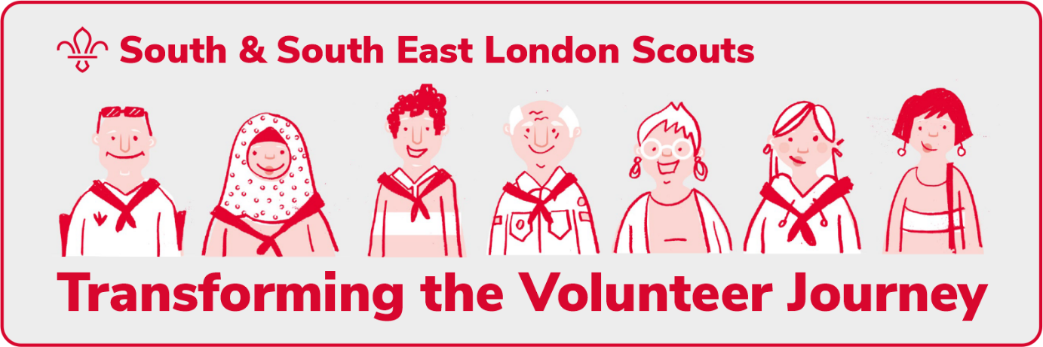
Since our skills for life strategy was launched, the steps taken by our county have helped to support our volunteers and equip many more young people with skills for life through our amazing programme.

But, during the pandemic, we couldn’t carry on as normal. We rallied and responded to the challenge, adapting scouting to meet new realities, and refocused on retention rather than growth. Doing all that was tough on all of us. It also meant pausing full implementation of our strategy plans.

Now, as we look to the future, with a renewed appreciation that scouting has never been more needed, it’s time for us to recommit to implementing our strategy and focus on the next two years, as we look to realise all the objectives in the plan that we agreed together at our county conference in 2018.

Transforming the volunteer journey
As part of delivering the national skills for life strategy, the way we volunteer is being transformed.

The aim is to deliver a more compelling volunteer offer, that demonstrates the value and benefit of being an adult in the scouts. In turn this will help you recruit more leaders and will help ensure our volunteer roles are modern, manageable, and fit for purpose. Including things like a warmer welcome and joining process and flexible learning opportunities.
This is how volunteering will look…
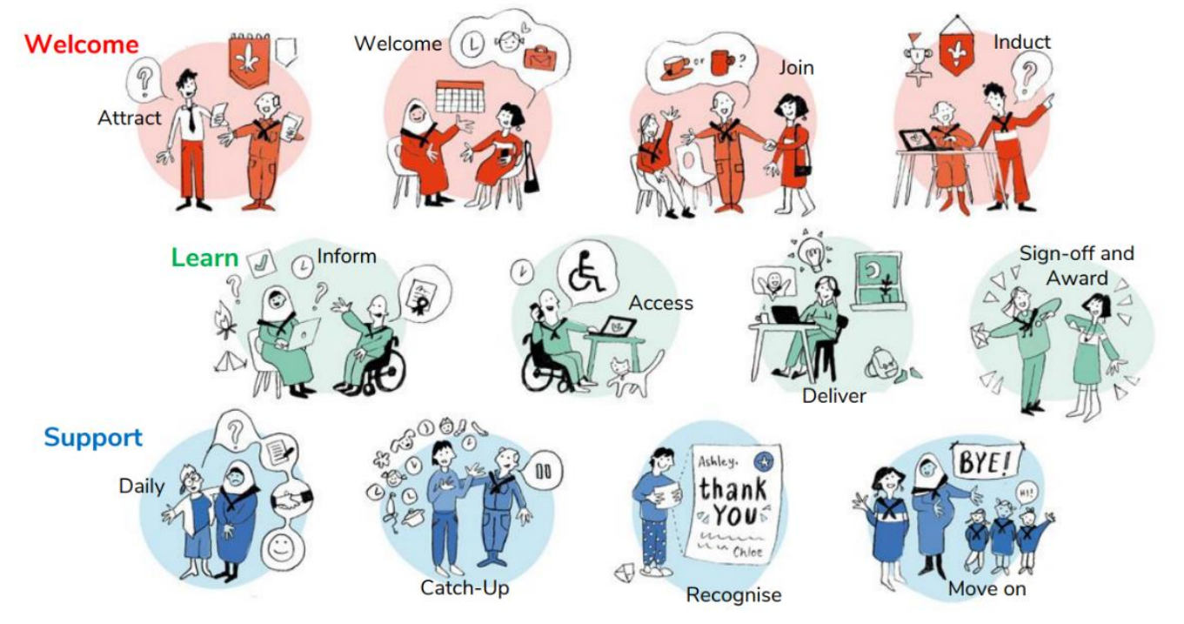
Ultimately, we want to make sure every volunteer is welcomed, supported, valued, gains skills and has fun!

To do this teams of volunteers across the UK are working to create a modern and fit-for-purpose volunteering culture with skills for life at the core (that’s volunteer-centric too).
What’s changing…

Change 1: A warmer welcome for everyone
Historically we have appointments panels to welcome new volunteers into their role. The panels are an important step in our appointment process and help us keep young people in scouting safe.

However, the current appointments process is somewhat intimidating, unclear and rarely as welcoming as it could be. It can also be really off-putting for potential volunteers, meaning they don’t get involved.

We are moving to a much warner way of welcoming new adults, and this means changes to our appointment process. This will include a welcome conversation in place of the formal appointments panel. Conversations will be group led and happen where the new adult volunteers. To compliment this there will be better support for inductions.
Change 2: A more engaging learning experience
Learning needs to be flexible, accessible, and easy to deliver and record. We know people learn best through a combination of online and in-person learning, so our approach will be digital first but will include workshops and ‘on the job’ stuff. There will be networking opportunities too.

The focus will be on learning that’s engaging, relevant and enjoyable. This will mean that there will be some learning that everyone who volunteers with us needs to complete (core learning) but most of the learning and completing a wood badge will be optional.

If an adult chooses to complete their wood badge, they will be able to customise and define their learning needs and the subjects they take part in, so they will learn what’s relevant to them in ways that make sense.

There won’t be much validation, we are cutting down to make sure the focus is on the practical stuff that helps all of us to be better. There will also be ways to recognise prior learning or existing skills, so there’s no need to go over areas that people already know.
Change 3: More support to help you get everyday things done
This change involves some changes to our volunteering structure and making our adult roles easy to understand, manage, and flexible.

Experience shows us that asking people to become leaders or take on other specific roles doesn’t suit everyone and makes it difficult to recruit people to help out. With the pressures of today’s busy lifestyle, people need to be able to volunteer in the way they can and want to, focusing on the areas they have skills or interest in – and without having to take on a role which comes with a list of responsibilities and tasks.

Our teams thrive when they share a purpose and tasks and support each other to make things happen in the time they have available. So, we are moving to team-based volunteering. This means that tasks could be assigned based on who’s most interested or suited, opening new opportunities and helping to make volunteering more flexible and enjoyable

scouts.org.uk will also include everyday membership management tools that will better integrate with how we do things. This will result in a simpler, slicker, more joined-up volunteering journey.

Leading national change
Over the coming months we will start to think about how we are going to implement the national volunteer transformation, ensuring county wide consistency, as part of the national skills for life strategy.

To help steer these changes our county leadership team has appointed a county change team which is supported by our county development service to ensure that a focus is maintained on the steps we need to take to support our groups, units and districts in preparing for and making the changes in a way that will not overwhelm local scouting. You can take a look at who is on the team HERE
The way forward – our timeline
Following national feedback, the national rollout timeline has recently been revised. The 10 early adopter counties around the UK will now go live on the new digital system in November 2023 and the rest of the counties (including us), will go live on the new digital system in January 2024…

Our rollout timeline is:

In December 2022 we will:
- share our plans with districts, groups, and units (this briefing!)
- update our training advisers and wider training community

From January to December 2023, we will:
- continue to communicate about the changes
- continuously monitor the rollout of our of local change plans
- support the cleaning of the data currently held in Compass

In January we will:
- talk to you about how you can easily help with updating and cleaning the records held on compass for the adult in your group
- tell you more about our new volunteering structure and the positive impact of changing to team roles
- support District’s in launching Volunteer Development Teams (initially with an appointments focus)
- meet with our Training Advisers

In February we will:
- start to roll out welcome conversations (and wind down appointments sub-committees)
- complete the launch of District Volunteer Development Teams

In March we will:
- Provide you with tools to help you think about how current roles fit into new teams and how you can plan for the future

In April we will:
- tell you more about the small changes to local Trustee Boards (so you can prepare for your AGM)

In May we will:
- take a step back, review how things are going, and provide an opportunity for you to get even more information, support, and guidance

In June we will:
- Look at what District Support Teams will look like (currently Scout Active Support)

In September we will:
  - support District’s to launch…
    - District Leadership teams
    - District 14 to 24 teams
    - District Programme teams

In October we will:
- move from Scout Active Support to District Support Teams
- look at the road from training to learning
- identify the I.T. support needed and recruit local I.T. champions
- complete Compass data cleaning and check email addresses

In November we will:
- share ‘Our National Volunteering Culture’ locally
- support groups in moving to the new team roles structure
- support local readiness so we can hit the ground running in 2024

In December we will:
- celebrate successes and look forward

From January to March 2024, we will:
- provide support for new digital systems
- provide ongoing support
- move to the new learning framework
- collect your feedback so we can support UKHQ in the development of future digital systems

This is subject to tweaks and changes based on information that becomes available from UKHQ during 2023.
If you have any questions, please email Matt matt.butterfield@southlondondonscouts.org.uk

You can also find out more at www.southlondonscouts.org.uk/skillsforlifeplan
Please save paper – think before printing this email.
You have received this email because you hold an manager’s role in South London Scouts.
You can find more information on how we use your personal data to administer your members and training at www.southlondonscouts.org.uk/about/privacy-notice

We will continue to develop this email to ensure we provide the best possible support
Contact us….
Email: contact.us@southlondonscouts.org.uk
Website: www.southlondonscouts.org.uk
Phone: 0843 289 0712

County directory: www.southlondonscouts.org.uk/about-us/county-directory

