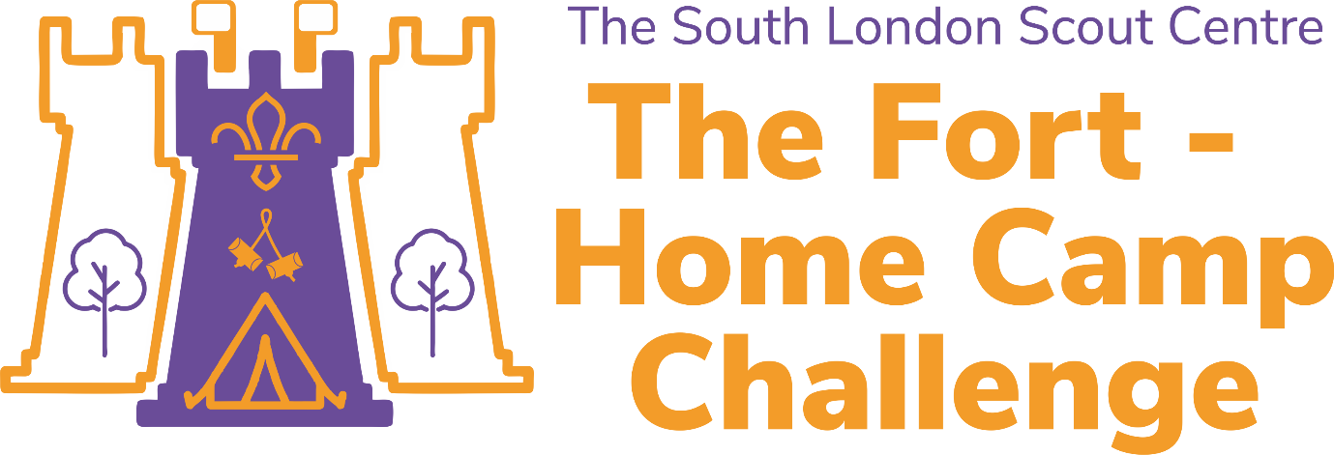

The South London Scout Centre - known as The Fort, is the home of South London Scouts. As scouts we love to go camping, but as we cannot go camping together at the moment, we have an exciting camping challenge for you to complete at home.

There is something genuinely magical about spending a night under the stars, listening to the sounds of nature as you cosy up in your sleeping bag.

We have designed a camp programme for you to take part in. The best way to take part is to speak to a few of your scout friends and arrange with them to complete the programme at the same time. if you successfully complete our camp programme you will be awarded our special 'The Fort - Home Camp Challenge activity badge.' Use the table below to record your achievements and give it to your leaders either by email or next time you see them.
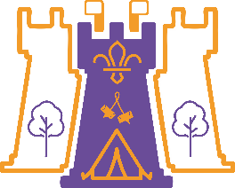 | The Fort –  Home Camp Challenge
Record of achievements
Challenge Element |  |  | Completed þ
Checklist
 | 1 | Read through the activity checklist and discuss each point with an adult.
Your Kit
 | 1 | Complete the kit quiz for your section.
 | 2 | Get you kit together and pack you bag.
Your Uniform
 | 1 | Get your uniform ready.
 | 2 | Wear your uniform when you see the scarf icon on an activity.
Challenge Element |  |  | Completed þ
Your equipment
 | 1 | Read through our equipment.
 | 2 | Ensure you have everything you need to take part in the activities.
Camp opening
 | 1 | Complete the flagpole challenge.
 | 2 | Take part in your camp opening.
Your camp
 | 1 | Build you camp (build your den or put your tent up).
Let’s do lunch!
 | 1 | Make a disgusting sandwich and try it.
 | 2 | Make you pack lunch and eat it n camp.

Challenge Element |  |  | Completed þ
Afternoon activity
 | 1 | Complete one of the listed afternoon activities.
 | 2 | Talk to your friends about how you got on with the challenge.
Gordon the warden’s crazy challenge!
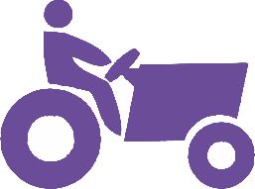 | 1 | Complete Gordon’s crazy challenge in the time given.
Dinner time
 | 1 | Complete the ready, steady, cook challenge and eat the meal that you prepare.
 | 2 | With an adult, help make camp doughnuts!
Camp fire
 | 1 | Build your campfire.
 | 2 | Sing along with your friends (if you can) to at least three campfire songs.
Challenge Element |  |  | Completed þ
Main feature
 | 1 | Watch one of the suggested films.
Lights out
 | 1 | Spend the night sleeping in your den or tent.
Morning campers!
 | 1 | Cook and eat your breakfast.
Dress to impress
 | 1 | Complete our dress to impress challenge.

Challenge Element |  |  | Completed þ
Team challenge…
 | 1 | Complete our team challenge with at least two of your friends.
Strike camp
 | 1 | Pack your tent away/take your den down.
 | 2 | Pack your kit.
Camp close
 | 1 | Take part in your camp close.

